**Module-2: MULTIPLE INHERITANCE**

**Inheritance:**

Inheritance is a **fundamental concept** in object-oriented programming (OOP) that allows a **new class** (known as a subclass or child class) to inherit **properties** and **behaviors** (**fields** and **methods**) from an **existing class** (known as a **superclass** or **parent** class). This promotes code reusability and establishes a natural hierarchical relationship between classes.

**Key Points:**

**Super Class (Parent Class):** The class from which properties and methods are inherited.

**Example:** Animal might be a superclass.

**Sub Class (Child Class):** The class that inherits from another class. It can add its own properties and methods, or override the inherited ones.

**Example:** Dog might be a subclass of Animal.

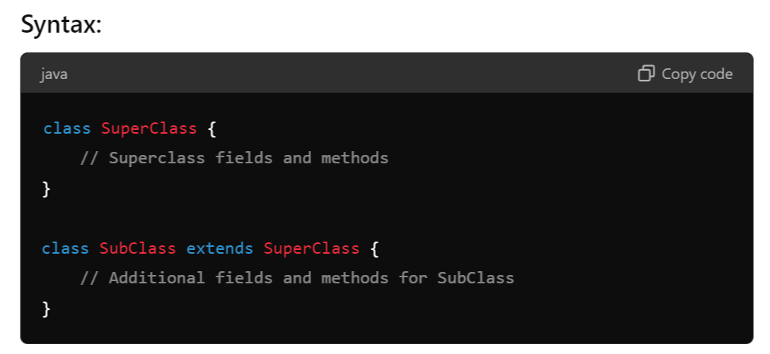

**Example:** In the below example we have 2 class One is Animal and Dog, and Animal is a Parent class and Dog is a Child Class.

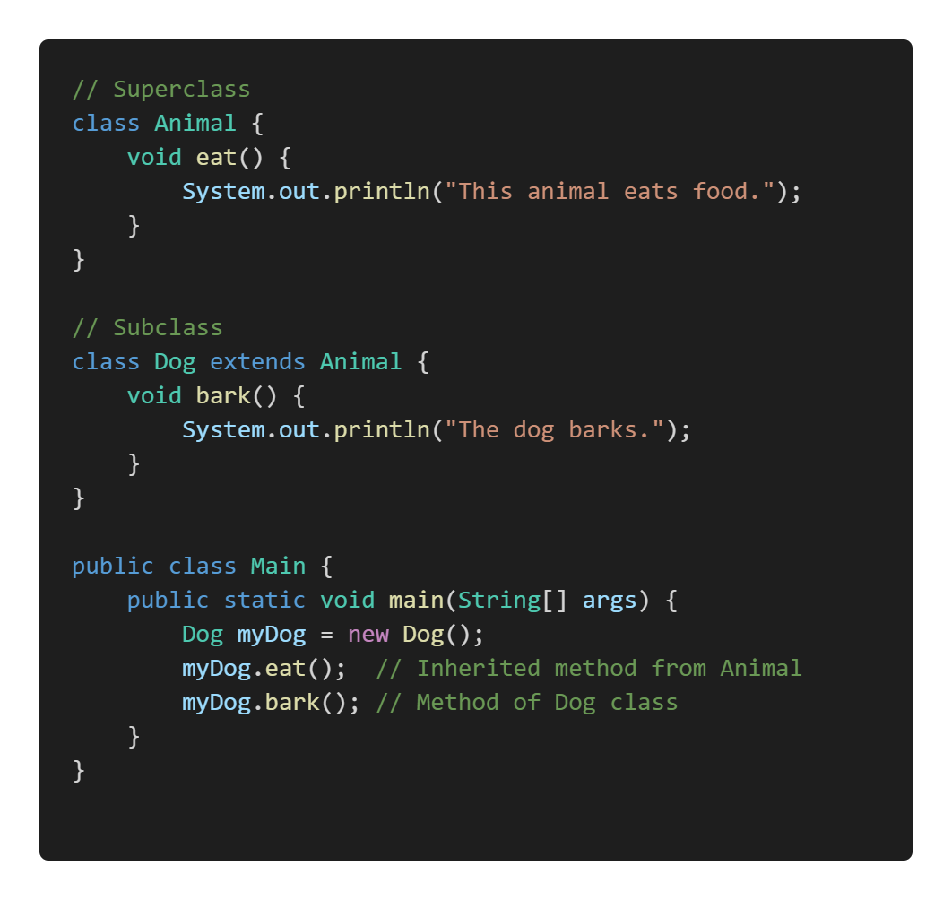

**Inheritance Hierarchies:**

An **inheritance hierarchy** represents the relationships among classes in a multi-level manner, where classes are derived from other classes in a chain.

1. **Single Inheritance:** A subclass inherits from only one superclass.
2. **Multi-Level Inheritance:** A chain of inheritance where a class is derived from another derived class.
3. **Multiple Inheritance:** A class derived from more than one Super class.
4. **Hierarchical Inheritance:** Multiple subclasses inherit from a single superclass.
5. **Hybrid Inheritance:** A combination of more than one type of inheritance.

**Note:**

Java doesn't directly support multiple inheritance due to the **Diamond Problem**, but it can be achieved through interfaces.

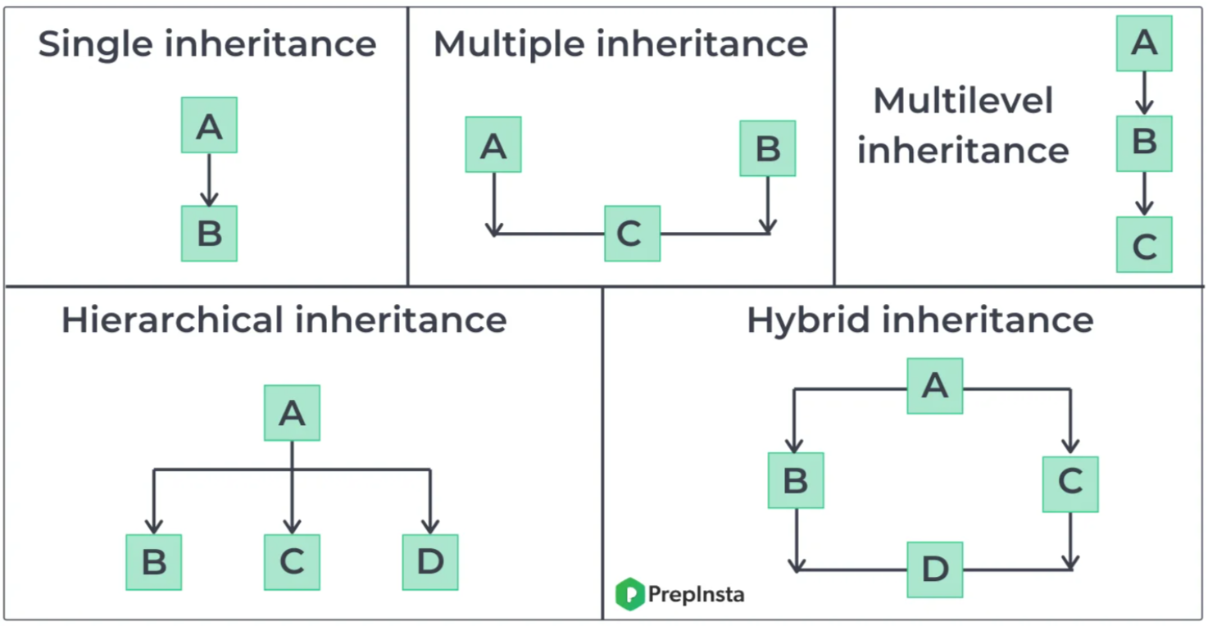

1. **Single Inheritance:**

Single inheritance means **one class** inherits from **only one** parent class.

**Example:**

1. **Multilevel Inheritance**

Multilevel inheritance occurs when a class inherits from a class, which in turn inherits from another class. It forms a chain of inheritance.

**Example:**

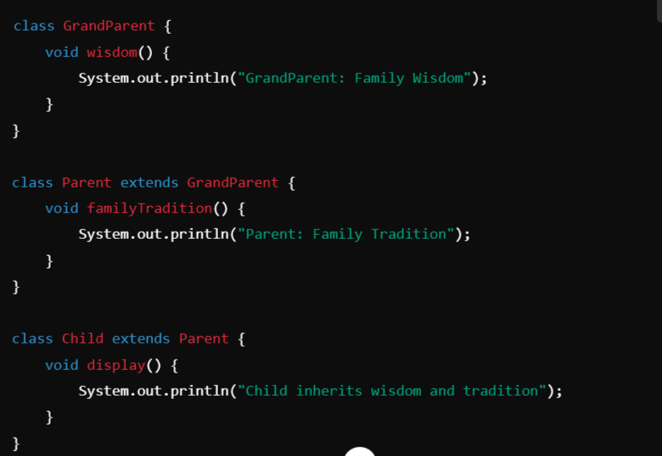

### ****Hierarchical Inheritance****

Hierarchical inheritance occurs when **multiple classes inherit from a single parent class**.

**Example:**

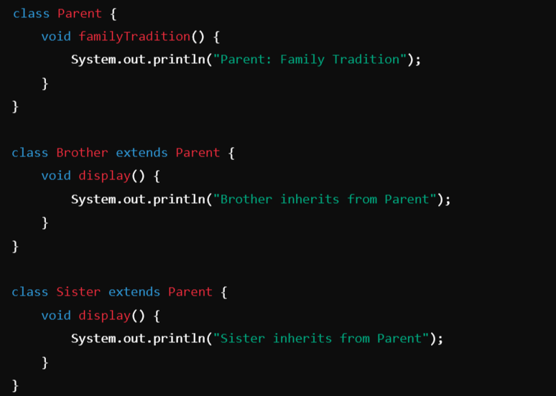

### ****Hybrid Inheritance (Using Interfaces)****

Hybrid inheritance is a mix of two or more types of inheritance. Java doesn’t support multiple inheritance directly through classes, but you can achieve it using **interfaces**.

**Example:**

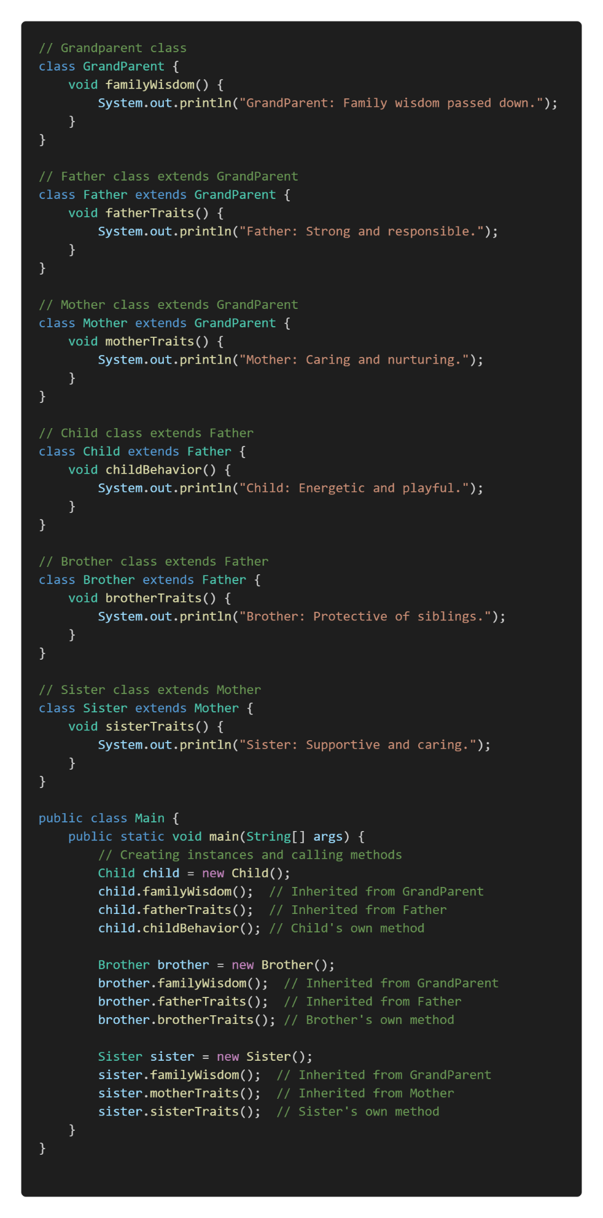

**super Keyword:**

**The super keyword in Java is used in three main contexts:**

1. Accessing the **Parent Class Constructor**
2. Accessing **Parent Class Methods**
3. Accessing **Parent Class Fields**

Overall, super is mainly used to **differentiate** **between members of a parent class and the current class,** ensuring the correct fields, methods, or constructors are accessed.

**Note:** The super keyword is used to refer to the immediate parent class. However, super can **only be used within a method or a constructor**. You cannot use super directly in the class body.

**1. Accessing the Parent Class Constructor:**

It is used to call a constructor of the parent class from a subclass. This is typically done to **initialize the parent class's fields when an instance of the subclass is created**.

**Example:**

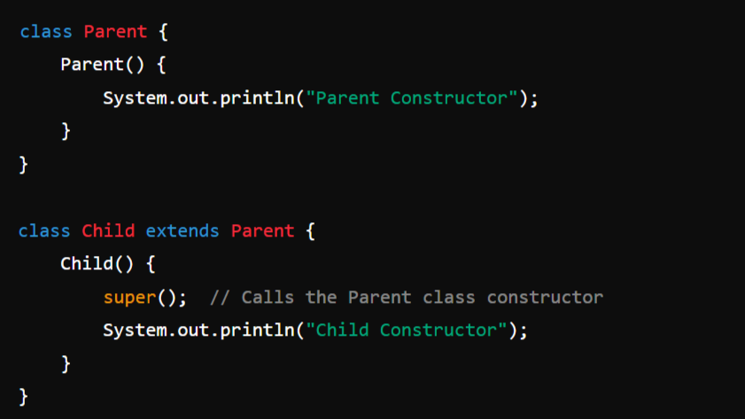

**2. Accessing Parent Class Methods:**

super can be used to call a method from the parent class that has been overridden in the child class.

**Example**:

**3. Accessing Parent Class Fields:**

If a field in a subclass hides a field in its superclass, super can be used to refer to the superclass's field.

**Example:**

**final** Keyword:

In Java, the keyword final is used to declare constants, restrict inheritance, and prevent method overriding or reassignment. It can be applied to **variables**, **methods**, and **classes**, each serving a specific purpose.

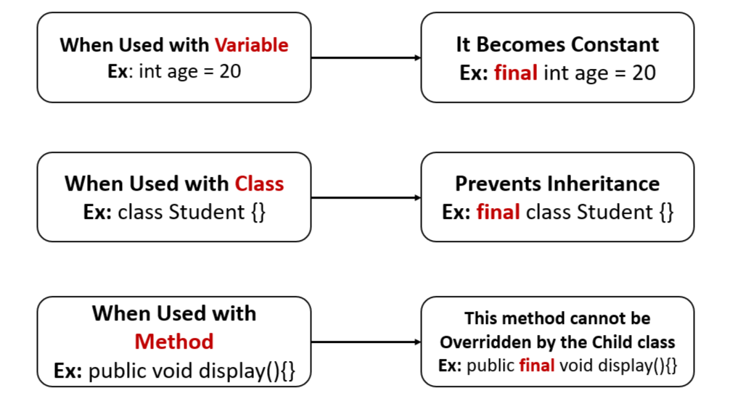

**final** **Classes and Methods:**

In Java, the final keyword can be used to mark **classes**, **methods**, and **variables**. When applied to a class or method, it has specific effects:

1. **final Classes:**

A **final class** is a class that cannot be **subclassed** or **extended**. This is useful when you want to prevent other classes from inheriting your class, ensuring that its implementation remains unchanged.

**Syntax:**

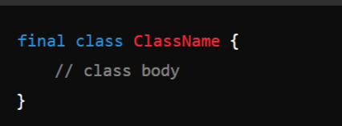

**Example:**

**2. final Methods:**

A **final method** is a method that cannot be **overridden by subclasses**. This is useful when you want to ensure that a method's implementation remains unchanged in any subclass.

**Syntax:**

**Example:**

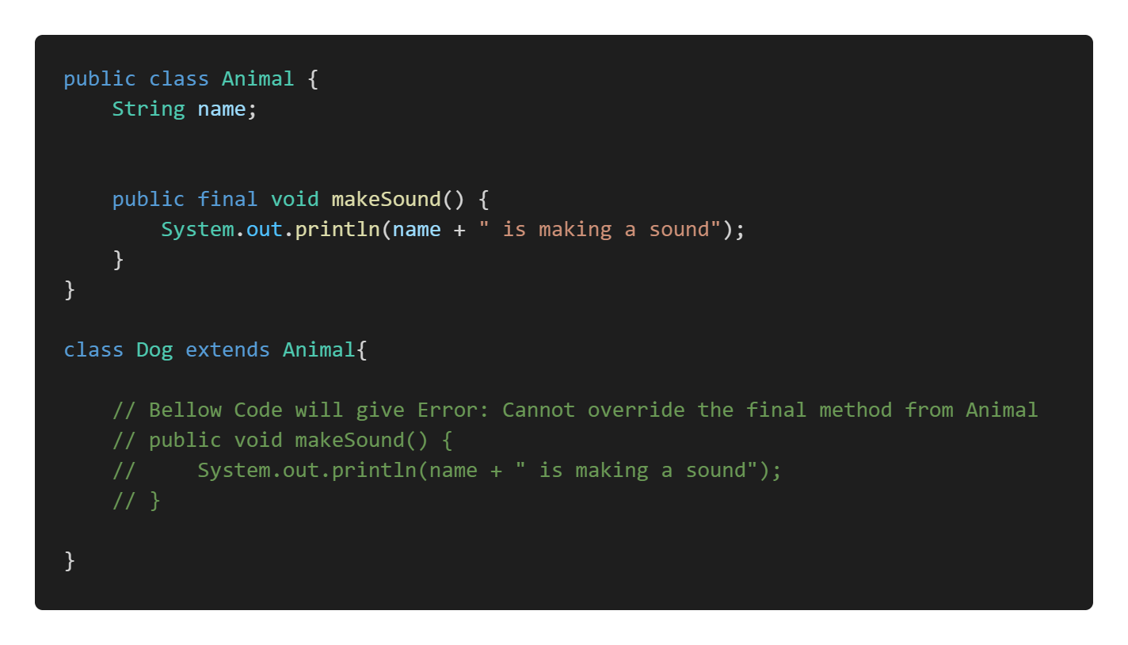

**Object Class:**

In Java, an Object is the root class of the Java class hierarchy. Every class in Java is implicitly a subclass of the Object class, either directly or indirectly. This means that all Java classes inherit the methods defined in the Object class.

When I say "**every class in Java is implicitly a subclass of the Object class**," I mean that no matter what class you create in Java, it **automatically inherits from the Object class**, even if you don’t explicitly specify a parent class. This inheritance happens by default.

**Methods of Object Class:**

Object class is present in **java.lang package**. Every class in Java is **directly** or **indirectly** **derived** from the Object class. If a class does not extend any other class then it is a direct child class of Object and if extends another class then it is indirectly derived. Therefore the **Object class methods** are available to all Java classes. Hence Object class acts as a root of the inheritance hierarchy in any Java Program.

**Methods:**

1. **toString():** Returns a **string representation** of the object.

**Syntax:**

**public String toString()**

**Example:**

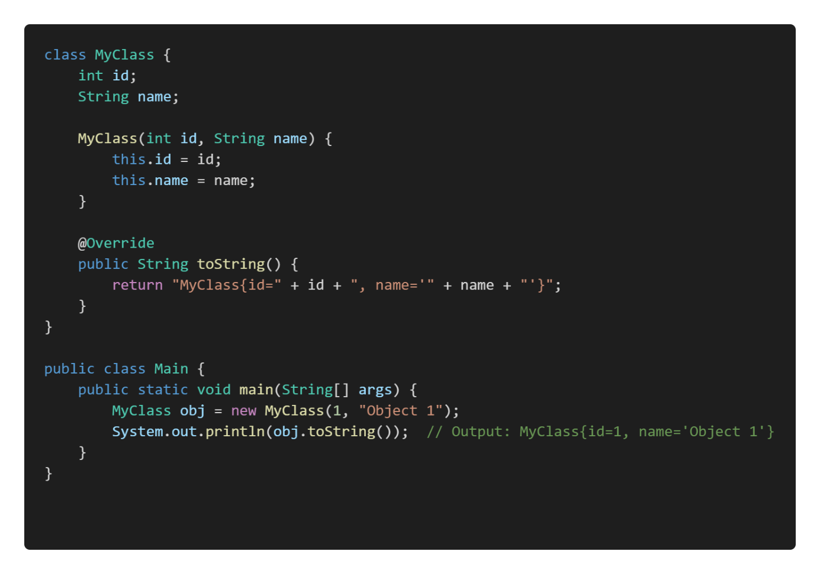

**2. equals(Object obj):** Compares **this** object with the **specified object** for equality.

**Syntax:**

**public boolean equals(Object obj)**

**Example:** The equals method in the above example is a custom implementation of the equals() method in Java. This method is used to compare two objects for equality, and it’s typically overridden in classes where you want to define what it means for two objects to be considered "equal."

**3. hashCode():** Returns a **hash code value** for the object, which is used in hashing-based collections like HashMap.

A hash code value is an integer that is generated by the hashCode() method in Java. This value is used to uniquely represent an object in hashing data structures like HashMap, HashSet, and Hashtable.

**Syntax:**

**public int hashCode()**

**Example:**

**4. clone():**

Purpose: Creates and returns a copy (clone) of the object. The class must **implement** the **Cloneable interface**.

**Example:**

**5. finalize():**

The finalize() method in Java is a special method that the garbage collector calls before an object is removed from memory. It allows the object to perform any cleanup operations, such as releasing resources or closing files. However, it is **rarely used** because relying on finalize() can lead to unpredictable behavior. So this will be handled by the Garbage Collector Automatically.

**Syntax:**

protected void finalize() throws Throwable

**Example:**

**6. getClass():** Returns the **runtime class** of the object.

In Java, the getClass() method is used to obtain the runtime class of an object. The runtime class of an object refers to the **actual class type of the object** as it exists during the execution of the program, not necessarily the type as known at compile time.

**For example,** if you have a variable declared as Object but it actually references an instance of String, calling getClass() on that variable will return the Class object representing String. This can be useful for reflection, debugging, or when you need to perform operations based on the exact type of the object at runtime.

**Example-1:**

**Example-2:**

**7. notify() :**

In Java, the notify() method is used in **multi-threaded programming** to **wake up** a single thread that is **waiting on the object's monitor** (lock). Here's a brief explanation:

1. **Context:** When multiple threads are involved in a task, some threads might need to wait for certain conditions to be met before they can proceed. This is typically done using the wait() method, which causes a thread to wait until another thread notifies it that it can continue.
2. **Usage of notify():** The notify() method is called on an object to wake up one of the threads that is currently waiting on that object's monitor. Only one thread is awakened, and it is chosen by the JVM (Java Virtual Machine) in a somewhat random fashion if multiple threads are waiting.

**Syntax:**

public final void **notify**()

**Example:**

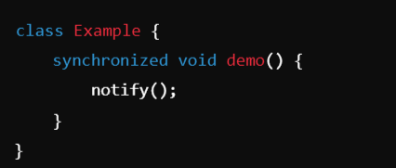

**Synchronized Method (demo()):**

The demo() method is marked as **synchronized**. This means that when a thread calls demo() on an instance of Example, it acquires the **lock** (monitor) on that instance before executing the method.

**Only one thread** can execute the demo() method at a time on the same object. If another thread tries to call demo() or any other synchronized method on the same object, it will block (wait) until the lock is released.

So here only one instance of Example will hold the control until and unless it calls the demo() method and inside it will execute the notify() method to release the lock, so that other objects can access it. notify() is used to wake up one thread that is waiting on the object’s lock (monitor).

**8. notifyAll():** Wakes up **all threads** that are waiting on this object's monitor (**Internal Lock**). This lock, or monitor, is a mechanism that ensures that only **one thread** can access a synchronized block or method on that object at a time.

**Syntax: public final void notifyAll()**

1. When a thread calls notifyAll() on an object, all threads that are currently waiting on that object's monitor (using the wait() method) are awakened.
2. These threads do not immediately resume execution; they must re-acquire the lock on the object before they can proceed. Since only one thread can hold the lock at a time, the awakened threads will compete to acquire it.
3. Like notify(), notifyAll() must be called from a synchronized context, meaning the thread must have the monitor (lock) of the object.

**Example:**

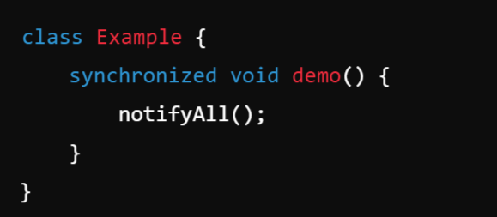

**9. wait()** and **wait(long timeout):**

Causes the **current thread** to **wait** until another thread invokes **notify()** or **notifyAll()** on this object. So the wait() method will make the current thread **pause its execution** until another thread **signals it to continue.**

**Syntax:**

**public final void wait() throws InterruptedException**

**public final void wait(long timeout) throws InterruptedException**

**Example:**

The **wait(1000)** method is called inside demo(), which tells the **current thread** to **wait** for up to **1,000 milliseconds** (1 second).

This method causes the **current thread to release the lock** on the object (in this case, the instance of Example), and the thread enters a waiting state.

**Polymorphism:**

In Polymorphism **Poly means many, morphism** **means** **form** together it says **More than One Form**.

Polymorphism allows **objects of different classes** to be treated as **objects of a common superclass** (through Method Overriding or Dynamic/ Late Binding). It is mainly achieved through **method overriding** (runtime polymorphism) and **method overloading** (compile-time polymorphism).

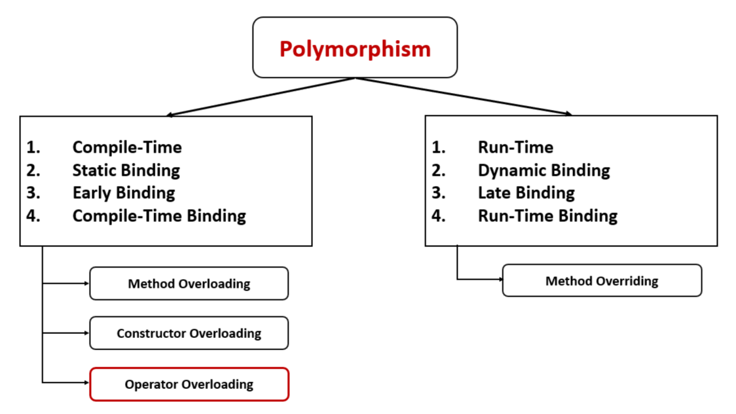

**1. Compile-Time Polymorphism (Static Binding or Early Binding):**Static binding, also known as early binding or compile-time binding, refers to the process where the method to be executed is determined at compile time rather than at runtime. This is in contrast to dynamic binding, which occurs at runtime.

**Method Overloading and Constructor Overloading:**

Method Overloading and Constructor Overloading in Java are concepts that allow **multiple methods** or **constructors to have the same name but different parameters** within the same class. They help improve code readability and flexibility by enabling the same method or constructor to perform different tasks based on the input parameters.

**1. Method Overloading:**

**Definition:** Method overloading occurs when two or more methods in the same class have the same name but differ in the number or type of parameters.

**Key Points:**

* + Methods must have different parameter lists (either in **number**, **type**, or **order** **of** **parameters**).
  + The return type can be the same or different, but it doesn't influence overloading.
  + Overloading enhances code readability and reusability.

**Example:** In this example we can see that the method add is overloaded 3 times based on num of parameters passed to it. So we have 3 methods with same name but different num of arguments.

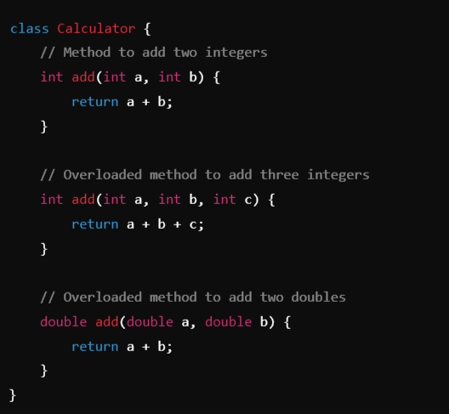

**2. Constructor Overloading:**

**Definition:** Constructor overloading occurs when a class has **multiple constructors** with the **same name** (the class name) **but different parameter lists.**

**Key Points:**

* + Allows creating objects in different ways depending on the arguments passed.
  + Like method overloading, constructors must **differ** **in** the **number**, **type**, or **order** **of** **parameters**.
  + It provides flexibility in initializing objects with different sets of data.

Example: Note: Constructer is a special form of method. So Constructor is indeed a method but it has some additional features.

**2. Run-Time Polymorphism: Dynamic Binding (Late Binding):**

Dynamic binding in Java refers to the process by which a **method call** is **resolved** **to the appropriate method implementation at runtime**, **rather than at compile time.** This concept is crucial for achieving polymorphism in object-oriented programming.

**Implementation:**

**Method overriding:**

**Method overriding** in Java is a feature that allows a subclass to provide a specific implementation of a method that is **already defined in its superclass**. This is used to achieve runtime polymorphism and enable the subclass to customize or enhance the behavior of the inherited method.

**Key Points of Method Overriding:**

1. **Same Method Signature:** The overriding method in the subclass must have the same name, return type, and parameters as the method in the superclass.
2. **Annotation:** The **@Override** annotation is often used above the method in the subclass to indicate that it is overriding a method from its superclass (though it is **optional**).
3. **Access Modifiers:** The access level of the overriding method **cannot be more restrictive** than the overridden method.
4. **Instance Methods Only:** Only instance methods (**non-static methods**) can be overridden. Static methods are not overridden but are hidden instead.

**Example:**

**Note:** To achieve a Method Overriding **there should be a Inheritance**.

In the below example we can see we have a Parent or Super cass Animal and a Child class Dog. Dog class is Overridden the method sound() which is present in the Animal class which is a Parent.

**Note:** **How to Prevent Method Overriding** --- Use **final** Keyword.

**Data Abstraction:**

Abstraction is the concept of **hiding the complex implementation details** and **showing only the essential features of an object**. In Java, abstraction is achieved using **abstract** **classes** and **interfaces**.

**Important:**

1. Abstract Class
2. Interface

**Example: Driving a Car**

When you drive a car, you don't need to know the intricate details of how the engine works or how fuel is converted into mechanical energy. You interact with the car through simple controls like:

* Steering Wheel: To turn the car.
* Accelerator Pedal: To increase speed.
* Brake Pedal: To slow down or stop the car.
* Gear Lever: To change gears.

So, The car's internal mechanics (like the engine, fuel system, transmission, etc.) are **hidden details**. You don’t need to understand these to drive the car.

The car's controls (steering, accelerator, brake) are the **abstracted interface** provided to you, the driver, to interact with the car.

**Abstract Classes and Methods:**

1. **Abstract Method:**

An abstract method is a method declared **without a body**. It must be overridden in the subclass. The method signature includes the **abstract** keyword, and there is no method body.

**Key Rules for Abstract Methods:**

1. Must be declared in an abstract class.
2. Cannot have a method body.
3. Subclasses that extend the abstract class must override the abstract method.
4. **Abstract Class:**

An **Abstract Class** in object-oriented programming is a class that **cannot be instantiated directly**. It serves as a **blueprint for other classes**. Abstract classes are used when you want to define some common behavior (methods) that other classes should inherit and implement, but the abstract class itself should not be instantiated. In other words, an abstract class can have **abstract methods** (without implementation) and/or **concrete methods** (with implementation).

**Example:** In the below example we have a abstract method named sound() without any body, so a concrete or normal class cannot have a abstract method, so that’s why the class is also made as abstract class.

Now, whichever class inherits the Animal class, they should provide the method body.

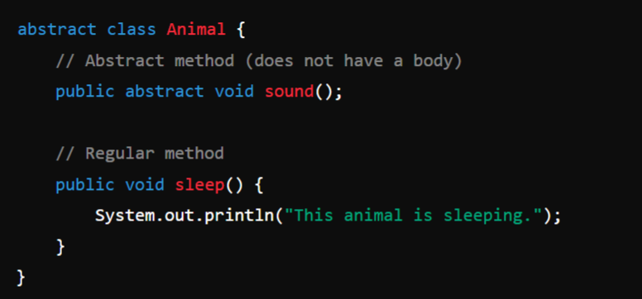

**Usage:**

Here we can see that the Dog and Cat both the class are child class to Animal, so they have provided the body to the abstract method sound() which is present in the Parent class Animal.

**Rules for Abstract Classes:**

1. Cannot be **instantiated.**
2. Can have **abstract methods.**
3. Can have **concrete methods.**
4. Subclasses **must override** abstract methods.
5. Subclasses can be **abstract.**